

|  |
| --- |
| 324 Project Proposal 2019  2019  2018 |
|  |
| August 6  Group Number: 18  ITRW 324 |



Contents

Group Members and Details: 3

INTRODUCTION 4

SHORT DESCRIPTION 5

WHY CREATE THIS APP? 6

FUNCTIONALLITY OF THE APP 7

POSSIBLE CHALENGES WE COULD FACE: 7

PLAN OF ACTION 8

TECHNOLOGIES AND IMPLIMENTATION 8

TEAMWORK METHODS & RESPONSIBILITIES 11

Gantt Chart 11

Reference list 12

## Group Members and Details:

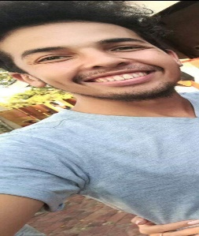Justin Sebonka

28571800 (group leader)

[Justin.Sebonka@gmail.com](mailto:Justin.Sebonka@gmail.com)

0761703872

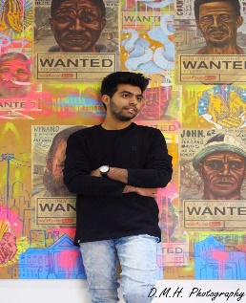

Aboobakr Omar

28552296

[AboobakrOmar.786@gmail.com](mailto:AboobakrOmar.786@gmail.com)

0797866007



Reinard Serfontein

25865234

[ReinardSerfontein@gmail.com](mailto:ReinardSerfontein@gmail.com)

0832875194

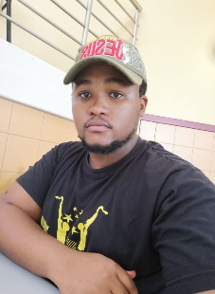Tshweu Sephiri

31255086

[31255086@student.g.nwu.ac.za](mailto:31255086@student.g.nwu.ac.za)

0817000063

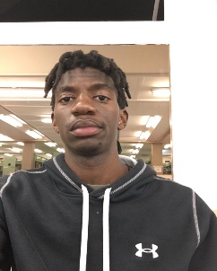Garikayi Pfumbidzayi

29574196

[29574196@student.g.nwu.ac.za](mailto:29574196@student.g.nwu.ac.za)

0742972316

|  |  |
| --- | --- |
| Group Member | Responsibilities |
| 28571800 (group leader) | Project leader & Web Developer – Front End Design |
| 28552296 | Web Developer – Front End Design |
| 25865234 | Web Develop – Front End & Back End Design, Database administrator |
| 31255086 | Mobile Application Developer_ Front End & Back End Design |
| 29574196 | Mobile Application Developer_ Front End & Back End Design |

## INTRODUCTION

In this report we will be discussing the project that our team decided to undertake this semester. A basic description, the motivation behind our idea, basic functionality, our basic plan to make sure that we will be able to do this project and time frames will also be included in this report. We will discuss the different methods, technologies and coding languages that will be used throughout the completion of our assignment. We will include the methods of teamwork we will be using throughout the creation of this project. We will also include the responsibilities of each member of the team in the report.

## SHORT DESCRIPTION

We have decided as a team to create an app that allows students to create their class timetables conveniently and efficiently. The app and possibly a website will require the student’s module codes and it will immediately create their very own personalized timetable without them having to make one manually. Why create this app if one student could just send the class timetable on the IT WhatsApp groups? This app will allow the students with extra or repeating modules to add their respective classes conveniently. Especially in the course we are doing at the moment, we have many integrated classes with the Computer Science students that only share one or two classes in common with us IT students so a class timetable is not always a” one size fits all” type of thing.

Keeping the user, which would be NWU students in mind throughout the creation of this project should not be a problem seeing as we are all NWU students so we will ultimately be solving our own problems with the creation of this app. Many times, the class timetables given by the university or fellow students do not allow you to make changes without physically messing up the appearance of the entire timetable. Our app will give students the freedom to add things such as test dates, assignment due dates, meetings, study times, gym times and many other things. This personalized timetable will allow you to constantly add update and delete information on your digital class timetable. This App will also send out notifications to its users a few hours before each class to remind them that they have class. We will only be doing a few classes applicable to the BSC IT final year classes just to prove that this application does everything we set it out to do.

## WHY CREATE THIS APP?

Most students receive a copy of their timetables from their fellow students at the beginning of the semester, take a picture of their timetables and use it off of their phones for the rest of the semester. This app will allow students to skip having to hunt for a time table to take a picture of but to come into each semester already having their very own class timetable that allows them to add many different things to it.

The period of time we are currently living is referred to as the ‘Golden Digitalization period’ according to Feigin. And this technological phase we are found in, is proven to be true by the engagement and expansion of the smartphone’s development. In the year 2018, over 1,2 billion smartphones were in operation all over the world's leading network providers (Feigin, 2015). It is reasonable to say that smartphones have become a person third hand and it is almost compulsory to have one within today’s society. The development and implementation of mobile applications is at its highest demand due to the increased numbers of smartphones (Feigin, 2015).

The North West University stated that there are over thirty thousand undergraduates enrolled at its Potchefstroom campus and each student requires a timetable to have an idea of class times, assignment due dates, test dates and other things that students need to keep track of. Our goal is to take the paper-based timetables provided by the school and integrate them into an app on all students’ smartphones. In our current academic environment, the class timetables are shared with all the information regarding every module divided by semesters and Degrees but often students have to repeat a module or have extra modules which results in them having to search and create their own timetable. The mobile application we are going to develop this process and it will be automated. Other features like push notifications will alert each student when, an assignment needs to get submitted later on in the day or tell students that they a have class in a few minutes (McClintock, 2014).

## FUNCTIONALLITY OF THE APP

When students are enrolled for their 1st year in the undergraduate program, at the North West University, the institution makes it a top priority to provide a paper based (hardcopy) timetable to the students.

Each student will have to fill in the sign up page in the app with a verified school email address and a password has to be created. Once this is successful, the application will allow the students to insert their module codes into the app and the codes are stored according to the dates and times reserved. Since the school offers both English and Afrikaans classes, the app will let the student choose their preferred language to operate in the app/website. A fixed calendar will at the home page of the website and this it will allow students to add important dates such test dates, assignment dates, meetings, study times, gym times, and numerous duties that need to be done by a student. This App will send its users notifications prior to each class, reminding the students that they do have class and that they have to start making their way to that class. With a database operating at the back, the mobile application can store information in the offline until a change has to be made.

## POSSIBLE CHALENGES WE COULD FACE:

* Adding the certain classes in the correct time slots by the push of a button.
* Resetting the entire timetable once the user has completed last week’s new added appointments.
* Storing each users’ original timetables so that it can be displayed on request.
* We could struggle with teamwork as we are not all used to working together.
* Learning how to work with multiple new technologies simultaneously could also be a big challenge.
* Miscommunication within our team could also be a factor.
* Synchronizing the servers and databases time with the local time for the push notifications that will remind students to go to class.
* Making sure that we stay on schedule.
* Notifying the user when there is a clash.

## PLAN OF ACTION

Our plan to ensure that we can successfully build this project would go as follows. We will firstly try to make a program that takes information about classes from our database then adds the appropriate classes 8in the correct slots in the time table. We would then have add, update and delete functions that allow you to personalize your timetable yourself. Personalizing the database on our basic program includes adding extra subjects, deleting cancelled classes and update the type of class you will be having e.g. : Normal classes changing to practical sessions, if the class is now a guest speaker slot or if a class is just there for questions.

Once we have that basic program then we can start trying to make our program into an app that can successfully communicate with the database which will be located on a completely different device. The app will have to communicate directly with our databases so that we can keep track of students’ original timetables so that we can give it back to them once they want to get rid of all the changes that they made. This is our basic plan of action; it may change somewhat throughout the entire semester. We will make use of only a few classes just to show that the project that we created actually works. The reason for this is that if it works for a few module codes then it will work once we put in more module codes.

## TECHNOLOGIES AND IMPLIMENTATION

Our group had a meeting to identify our weak and strong points so that we could identify roles in our group. When it came to coding, all five of us said that we are quite good with C# and java. All five members had experience working with databases and virtual machines as well. One group member pointed out that he is proficient in the php language but none of us have experience creating a mobile app. We decided as a group to go through a few coding courses related to mobile app development and websites as well. We finally decided on purchasing a java script course on Udemy because it came highly recommended by our peers especially for creating apps and websites.

The preferred programming language for a website development used by senior programmers across the world is JavaScript (Flynn, 2015). JavaScript is translated by a web browser and provides the interactivity and dynamics to the webpages (Jakus, Jekovec *et al*., 2010). JavaScript also supports communication between the servers. According to Antony (2012), using Adobe flash for the graphics of the website will provide a rich and quality visuals to the user. We are still in the process of finding a good course on app design, a few things came up such as UIX, UX and Bootstrap. The design aspect of our project is not the most important task at the moment. Our short-term goal for this project is to have the basic functions of the application in a working order before we try to make it look fancy and appealing to the user.

One of our options is to focus on the development of the applications will be on windows or Linux machines using Ionic framework with angular and JavaScript because the aim is to create a cross platform application that also has some native functionality, also known as a hybrid(Kucheriavy, 2015). Ionic has multiple advantages such as, it allows the developers to make mobile applications for both Android and iOS with using one code and provides custom build frameworks (Dymond, *et al*., 2012). Android studio is a second option to create android applications. It is ranked first when it comes to developing android applications and Swift will used to create the iOS application. Research is still being conducted to select the application development tool or platform that the group is going to use.

For this project we could make use of a Linux virtual machine on Ubuntu that will be created with Microsoft azure. MySQL database can be used to store the variables and apache is basically a web server software which hosts the web server (Flynn, 2015). Linux is an Operating system that sets the stack models foundation and all the other layers such as Apache, MySQL and PHP. We could make use of PHP and HTML to code in and to create the needed website that we are going to use for our project. The website that we might implement in our project would have to send and retrieve data from the online server constantly or every time the button is clicked to retrieve and set up the time table. The web server will have to constantly communicate with the app to ensure that the two work cohesively.

If the push notifications that will be send to the user notifications on the app do not work, we will not be able to notify our users about anything. We will have to use time intervals and ensure that the app has the same time zone as the database otherwise the user of the app will get notifications when they are not supposed to (McClintock, 2014). I think it is safe to say that the time zones being synchronized is extremely important. We will make use of time intervals to ensure that the app and the website is on the same time as the server. The program will have the options to be able to add and to delete any classes and other appointments that was added onto the time table. The app will be user friendly and any NWU student can make use of the app or the website.

The group decided to use Android Studio to create the mobile companion application, as 2 members of the group have knowledge and experience with the use of it. With more research regarding the operating system and web server, LAMP stack seemed to be the best option. According to Baheyeldin(2009), Lamp stack has numerous benefits such as a low entry barrier for developers and the most used open source stack. Lamp stack will allow us to run on a Linux machine or operating system. Instead of using a cloud server such as Firebase, Lamp stack provides a hosting system called Apache (Baheyeldin, 2009). MySQL will be the database used to store data and information for analysis when required. If LAMP is implemented, PHP will be used for the backend functionality. More research is required to assist the group with better options.

## TEAMWORK METHODS & RESPONSIBILITIES

We will make use of the scrum method that was demonstrated in one of our lectures. Our entire team worked very well with a scrum master making all of the 50/50 decisions. We were able to finish all our tasks in the given 2 minutes each time with all sorts of different scenarios. This made us confident to base our entire project on the scrum method. This method will give the entire team a clear overview for what has been done, what still needs to be done and what is busy getting done.

As for each group member, we will divide the work according to the different levels of skills that each member has. We will do so to ensure that each job that needs to be done, is done by someone that is more than capable of completing the task. We will support each other in every aspect of this project to ensure that we build a successful application and website that could ultimately make the lives of all the NWU students easier.

## Gantt Chart

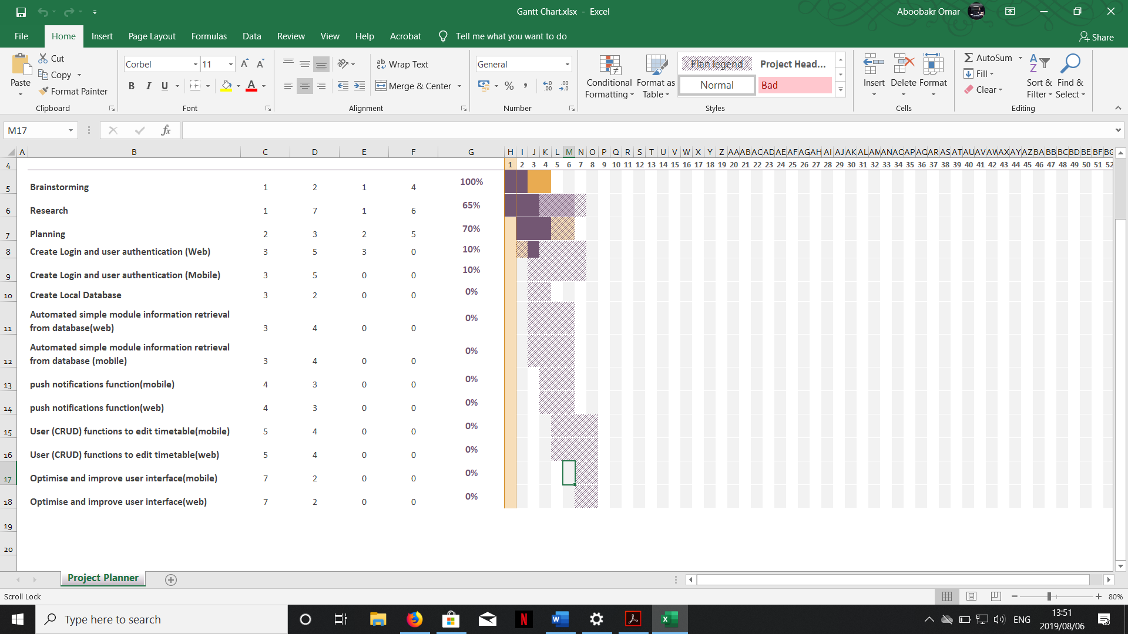

## Reference list

Chandi, l., Martinez, D., & Silva C. 2017. Mobile application development process: a practical experience.

Dymond, A., Esselaar, S., Kuek, S.C., & Quang, C.Z. 2012. Mobile applications for agriculture and rural development.

Feigin,B. 2015 .Mobile application development.

Flynn, C. 2015. 14 technologies every web developer should be able to use to explain. https://differential.com/insights/14-technologies-every-web-developer-should-be-able-to-explain/

Jakus, G., Jekovec, M., Tomazic, S., Sodnik, J. 2010. New technologies for web development. *Electrotechnical Review: Ljubljana, Slovenija:* 77(5): 273-280, 2010.

Kucheriavy, A. 2015. Which technology is best for my website. https://www.intechnic.com/blog/which-technology-is-right-for-my-website/ Date of access: 05/08/2019.

Beheyeldin, K. 2009. Linux, apache, mysql, perl/php/python.

Mandava, A. & Antony, S. 2012. A review and analysis of technologies for developing web applications.

McClintock, P. (2014). Met Opera Standoff Threatens $60 Million Theater Business. *The Hollywood Reporter*.